

###### Savitribai Phule Pune University A

**PROJECT REPORT ON**

**“Tomato Plant Leaf Disease Detection Using Image Processing With Help of Python**”

###### Submitted in partial fulfillment of the requirement for the award of the degree of BACHELOR OF ENGINEERING

**IN**

**ELECTRONICS & TELECOMMUNICATION ENGINEERING**

**By Kiran Sujgure**

**Harshal Patil Nilesh Dhepale**

**Under the guidance of Prof. Ms. S. S. PAWAR**



**DEPARTMENT OF ELECTRONICS & TELECOMMUNICATION ENGINEERING**

###### SANDIP FOUNDATION'S

**SANDIP INSTITUTE OF TECHNOLOGY& RESEARCH CENTRE**

**Mahiravani, Trimbak Road, Nashik-422213 2020- 2021**



**SANDIP FOUNDATION'S**

**SANDIP INSTITUTE OF TECHNOLOGY& RESEARCH CENTRE**

**Mahiravani, Trimbak Road, Nashik-422213, Maharashtra.**



This is to certify that, this Project report entitled- “**TOMATO PLANT LEAF DISEASE DETECTION USING IMAGE PROCESSING WITH HELP OF PYTHON”**

Submitted by Mr. Kiran Sujgure, Mr. Harshal Patil, Mr. Nilesh Dhepale for partial fulfillment of the requirement for the award of the **Bachelor of Engineering** in **ELECTRONICS & TELECOMMUNICATION ENGINEERING** as laid down by the

**SAVITRIBAI PHULE PUNE UNIVERSITY**, Pune. This is a record of their own work carried out by them under my supervision and guidance during the year 2020-2021.

Place: -SITRC, NASHIK

Date: -

Exam No.:

**Prof. Ms. S. S. Pawar**

**Guide**

**Dr. Mrs. G. M. Phade**

**Head**

DEPARTMENT OF ELECTRONICS & TELECOMMUNICATION

DEPARTMENT OF ELECTRONICS & TELECOMMUNICATION

**Examiner Dr. S. T. Gandhe**

**Prof.**

**PRINCIPAL (SITRC)**

#### ACKNOWLEDGEMENT

The work procedure in this report would not have been completed without the encouragement and support of many people who gave their precious time and encouragement throughout this period. We would like to sincerely thank our project guide **Prof. Ms. Swati Pawar** for her guidance and for the patience she showed us during the process of preparation of the project from the initial conception of final design and implementation.We would also like to extend our gratefulness to the Head of Department E and TC **Dr. Mrs. G. M. Phade.** Lab and library in charge for kindly granting us access to the lab. We would also like to thank the teaching and non-teaching staff who helped us from time to time with their own experience and also, we would like to express our gratitude to the core of our heart, principal **Dr. S. T. Gandhe** Sir for being supportive and always encouraging.

Kiran Sujgure Harshal Patil

Nilesh Dhepale

#### ABSTRACT

Agriculture is the mainstay of the Indian economy. Nearly 70% of individuals depend on it & share a majority of a neighborhood of the Gross domestic product. Out of that tomato is one of the simplest common food crops in India. Diseases in crops wholly on the leaves affect the reduction of every quality and quantity of agriculture. Perception of the human eye is not such a great deal stronger so as to observe minor variation inside the infected part of the leaf. Throughout this project providing software package resolution to automatically observe and classify plant leaf diseases. This approach will enhance the productivity of crops. This project's four-leaf diseases area unit is supported. It includes several steps-wise image acquisition, image pre-processing, segmentation, Feature extraction, for classification either we use K-means, CNN & SVM. The look at our implementation of Otsu segmentation, k-means clustering, Contrast Enhancement is absolutely automatic and it provides accumulated productivity. Also in the future, we are trying to develop a mobile application to detect the disease on tomato leaf.

**Table Content**

Acknowledgments Abstract

List of Figure i

Chapter 1 1

Introduction 1

Chapter 2 2

Literature Survey 2

Chapter 3 5

Problem Statement and Objective 5

* 1. Statement of the Problem 5
  2. Objective 5
  3. Social Impact 5

Chapter 4 6

Proposed system development 6

* 1. Proposed block diagram 6
  2. Block Diagram Explanation 7
  3. Software requirement 8

Chapter 5 9

Software Based Proposed System and Its Output 9

Chapter 6 15

Conclusion 15

|  |  |  |
| --- | --- | --- |
| 6.1 | Conclusion | 15 |
| 6.2 | Future scope | 15 |
| 6.3 | Advantages | 15 |
| 6.4 | Application | 15 |
| Chapter 7 | | 16 |

References 16

**List of figure**

###### Name of the Figure Page No.

|  |  |  |
| --- | --- | --- |
| Figure 4.1 | Proposed block diagram | 6 |
| Figure 5.1 | Proposed system block diagram | 9 |
| Figure 5.2 | Input disease affected leaf | 10 |
| Figure 5.3 | Output of Contrast Enhancement | 11 |
| Figure 5.4 | Output Otsu thresholding | 12 |
| Figure 5.5 | K-Mean clustering | 13 |
| Figure 5.6 | Feature Extraction | 14 |

# Chapter 1

Introduction

As per the survey of 2018, India stands 2nd in worldwide agricultural production. Agriculture employed more than 50℅ of the Indian workforces and contributed 17 – 18% to the country's GDP. India ranks first in the world with the highest net cropped area followed by the US and China, in India different States have taken a variety of crops. Plant diseases are the major contributors to reduce the potential of crop plants and ultimately reduce the production of agricultural products. Annual losses of crop production in India are estimated at 25% (NAAS, 2008), this indicates the importance and need for strengthening the existing biosecurity system more, so with advanced agriculture.

Each plant has a different type of disease found, so it takes a lot of effort and expect people to take care of those plants. In many parts of the country, farmers don’t have proper facilities and even an idea that they contact experts. Also, the consultation cost of experts is very high which adds an additional economic burden on the farmer. The process of consultation is also time-consuming [3]. Therefore, it is necessary to develop cost-effective technology to monitor the plants, which detect and identify diseases, insect pests, etc. Once the disease is identified, farmers can take necessary actions and precautions accordingly. With the rapid development of software and hardware technology, the application of image processing in agriculture has been developed [14]. In Image Processing, the image of the affected leaf of the plant is processed to identify the disease

# Chapter 2

## Literature Survey

Here, various papers describing the detection of various plant leaf diseases are studied. In paper [1], authors Kaushik N, Nikhil K G, Sulagna Sarkar implemented leaf disease detection technique and soil condition monitoring system using CNN. In this paper the digital image processing is integrated with machine learning concept which is achieved with the help of python to detect soil condition, leaf diseases, temperature, and moisture of the soil. CNN classifier is used to classify the images based upon their image characteristics. The author implemented an IOT based sensor to measure the temperature and moisture of the soil to make the system effective.

In paper [2], authors Faye Mohamed, Chen Bingcai, Kane Amath Sada implement a deep learning method to identify plant leaf disease, in which 3 deep learning models like VGG16, Google Net, and ResNet 50 used to get good accuracy. Using SVM and CNN classifiers features were extracted, results of DL methods VGG16, Google Net, ResNet 50 came out with accuracy of 97.82%, 95.3%, 95.38% respectively.

In paper [3], by authors Mr. Ashish Nage, Prof. V. R. Raut implemented leaf disease detection and identification based on python by using image processing. They proposed a system that is capable of detecting the disease in the early stage of growth of disease on the crop, which saves the loss and yield.

In paper [4], authors Shantanu Kumbhar, Amita Nilawar, Shruti Patil proposed a system that classifies the leaf image using image classification algorithm CNN. The user takes the images of the leaf and uploads in the system which detects the disease and also suggests to the user which pesticides the user has to use as a preventive measure.

In paper [5], by Abirami Devaraj, Karunya Rathan, they implemented and studied on Alternaria alternata, anthracnose, bacterial blight, and cercospora leaf spot, which is automatically detected by the image processing using MATLAB, Developing an automatic system for farmers for detection of disease in initial stages of crops.

In paper [6], by Peng Jiang, Yuehan Chen, Bin Liu, Dongjin He, they proposed an apple leaf disease recognition method based on real-time detection using an improved CNN classifier in the deep learning method. In this paper, they have an image dataset collected from a laboratory and a real apple

field, the dataset contains 90% of diseased leaves images, and by Using CNN classifier they recognize and detect the disease having high accuracy.

In paper [7], by Vishakha Lahu Bansod author represents a system for detection and classification of Rice crop disease based on Image of infected rice plant. In this Article various techniques used in Image Processing operation for feature extraction and segmentation of disease. They used the SVM Algorithm on infected leaves which detects color, shape, size and texture.

In paper [8], by Subhajit Maity, Sujan Sarkar, Avinaba Tapadar, Ayan Dutta, Sanket Biswas, Sayon Nayek, Pritam Saha have implemented K-Mean Clustering. In this paper, the leaf is categorized by texture, color, size and infected area by using image processing Technique. After the segmentation and clustering, the author gets the output as disease name and accuracy is represented in Histogram.

In paper [9], by S.S.Saranya, Nalluri Chandra Kiran, Komma Jyotheeswar Reddy they proposed a project which increases the growth of farming outputs, their system is using image processing method (SVM) for detecting affected leaves and identifying using edge detection, texture, diseases spots compared with combined Healthy and Unhealthy leaves dataset and it gives the result as Disease name.

In paper [10], by Xihai Zhang, Yue Qiao, Fanfeng Meng, Chengguo Fan, and Mingming Zhang implemented maize leaf diseases detection using improved CNN. They also mentioned other classification techniques like SVM etc. They worked on 9 types of maize leaves and for more accuracy they improved deep Convolutional Neural Networks models. Using CNN models, GoogleNet and Cifar10 systems generated high identification accuracy up to 98.9% and 98.8% respectively. This survey shows that it is possible to improve recognition accuracy by increasing the diversity of pooling operations.

In paper [11], by Shalini K J, Hema M D, Kavya J, Meghana B N, Jeevitha M C worked on the three-basic reason of disease that are bacteria, fungal and viral. They also tried to increase the accuracy, speed of disease detection, and disease classification using Raspberry pi 3 model B modules, so that the system can send the information to the farmer as soon as possible by GSM module to their cell phones.

In paper [12], by Saradhambal. G, Dhivya R. Latha S, R. Rajesh implemented an inventive idea to identify the affected crop and give remedial measures to agricultural fields. They used the K-Mean Clustering algorithm for analysis and segmentation of infected leaves.

In paper [13], by T. Thamil Azhagi1, K. Swethal, M. Shravani and A.T. Madhavi implemented a system having a Raspberry Pi module using Image processing to detect the disease. The picture of the leaf is captured through a high megapixel camera module, the captured picture is analyzed in Raspberry

Pi zero board using Image processing techniques, which displays the picture of the infected leaf, name of the disease, and the preventive measure it.

In paper[14], by Prof. Swati Pawar Ms.Shweta Patil Ms. Tejaswini Patil Mr. Nasruddin Shaikh,” Detection And Classification Of Unhealthy Regions Of Grapes Plant Using Texture”, IJSRD, T Vol. 5, Issue 04, 2017.

In paper [15], by Vijai Singh and A. K.Misra presented a survey on different classification techniques like SVM, CNN, K-Mean clustering used for detection of plant leaf disease and different algorithms for Image Segmentation of Leaf diseases images that can automatically detect and classify. They tested their algorithm on bananas, Beans, Lemon, Rose jackfruit, etc. Their project helps farmers to detect the disease in the early stages.

# Chapter 3

### Problem Statement and Objective

##### Statement of the problem

Plant Leaf disease is a major problem in today’s agriculture industry, by this project using Image processing methodology we are going to detect and identify leaf disease and its name, also providing preventive measure to farmers as per the disease.

##### Objective

* + - To identify Plant Leaf disease detection.
    - To identify the type of Disease and Classified into Different types.
    - To suggest the appropriate pesticide for Type of Disease.

##### Social Impact

* + - In village area, when the disease spread around all the farm then and then the farmer can detect this by its naked eyes. So to avoid this, automatic detection of disease using image processing this technique is used.
    - For rural areas, it is cost-efficient.
    - In food industries where green leafy vegetables are used, this project can detect the infected
    - Leaves of vegetables.

# Chapter 4

### Proposed System Development

##### Proposed Block Diagram

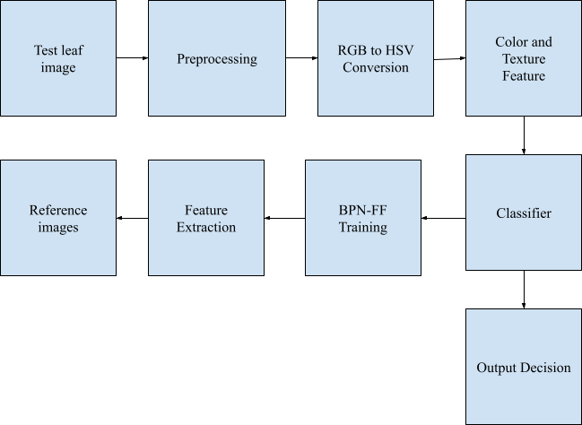

Figure 4.1: Proposed block diagram

##### Block Diagram Explanation

To classiﬁcation of diseases of Tomato leaf by our software we use the following Methods / process.

* + - **Image Acquisition -** The RGB color images are captured using a digital camera with a required resolution for good quality. The construction of an image database is clearly dependent on the application. The image database itself is responsible for the better efficiency of the classifier which decides the robustness of the algorithm

.

* + - **Image Preprocessing -** The image acquired is pre-processed. For classification purposes the image first needs to be clear which can easily identify the disease spot so we can do pre-processing tasks like enhancement of contrast, smoothing etc. Image preprocessing is done by adjusting intensity values and increasing the contrast of Image. For Contrast Enhancement, Cumulative Distribution Function Is Used.
    - **Segmentation-** The process of partitioning a digital image into multiple segments (sets of pixels, also known as image objects). The goal of segmentation is to simplify and/or change the representation of an image into something that is more meaningful and easier to analyze.
    - **Feature extraction**- After segmentation, the infected region various features are extracted to describe the infected region. Color, texture and shape-based features are normally used for region description. Color features are important to sense image environment, recognize objects and convey information.
    - **Classification-** It is the final stage in disease detection. It is identifying a rule according to selected features and assigning each disease to any one the predetermined classes. The artificial neural network and support vector machine, Convolutional Neural Networks, K-Mean Clustering are mostly used as classifiers.

##### Software Requirement

* + - Jupyter Notebook(anaconda 3)
    - Python IDE

# Chapter 5

### Software Based Proposed System and Its Output

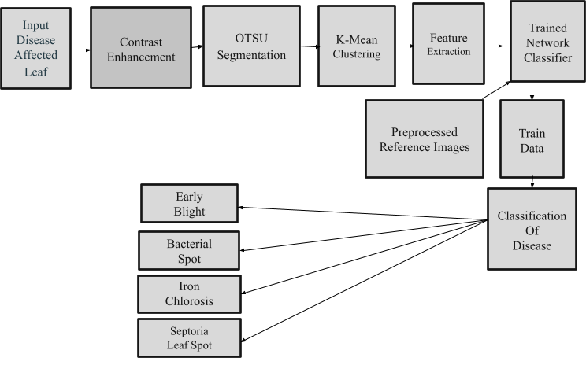

Figure 5.1: Proposed system block diagram

##### Step_1:-Input Disease Affected Leaf

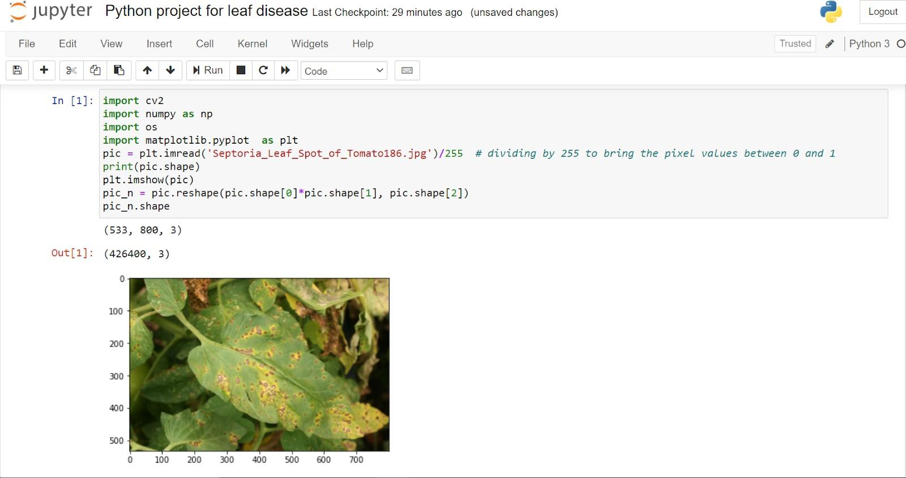

Figure 5.2: Input Disease Affected Leaf

##### Step_2:- Contrast Enhancement

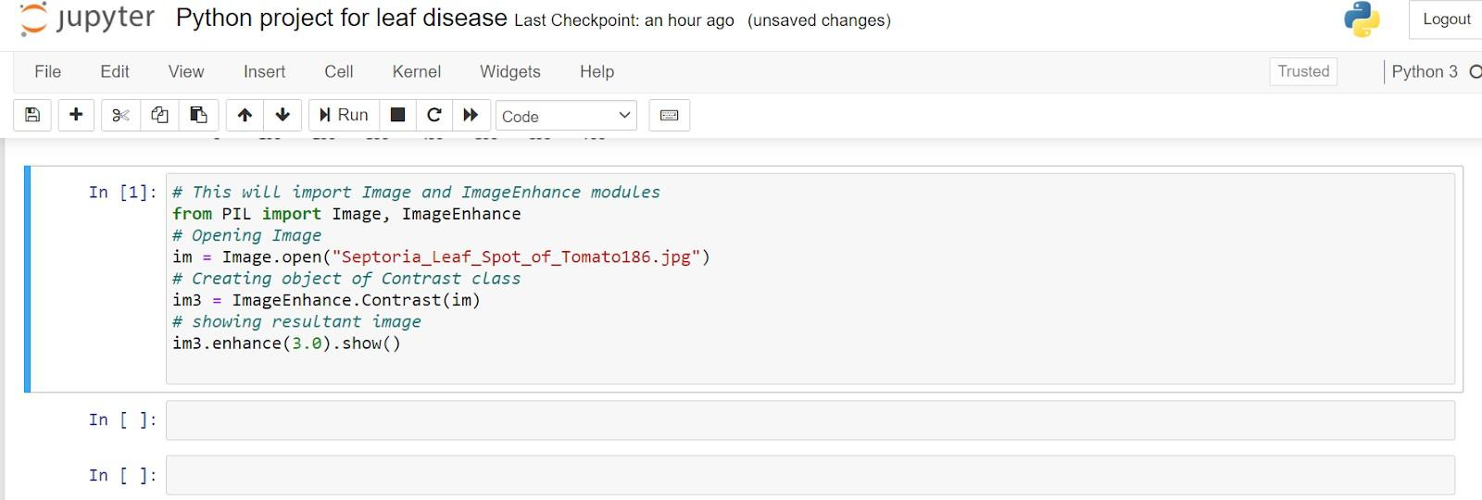

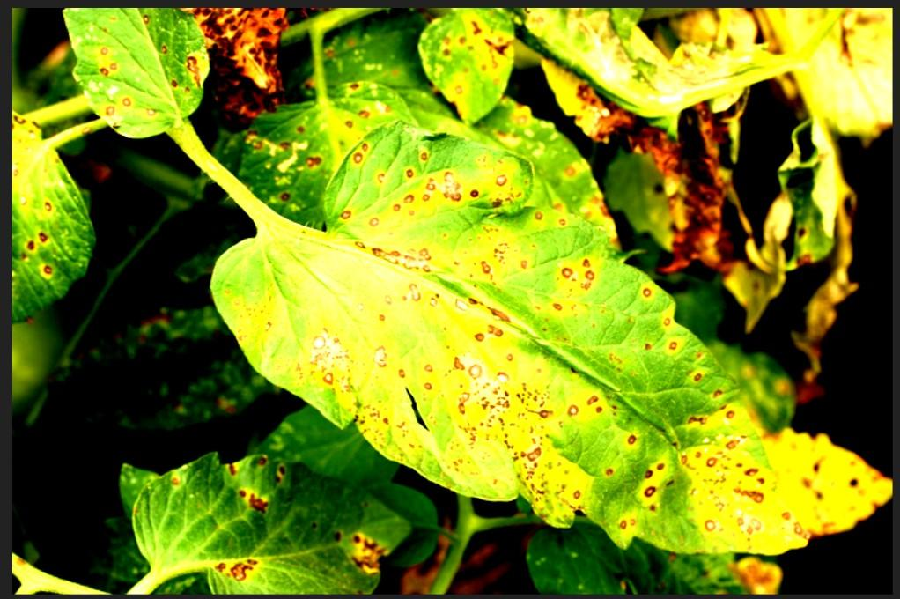

Figure 5.3: Output of Contrast Enhancement

##### Step_3:- Otsu Segmentation

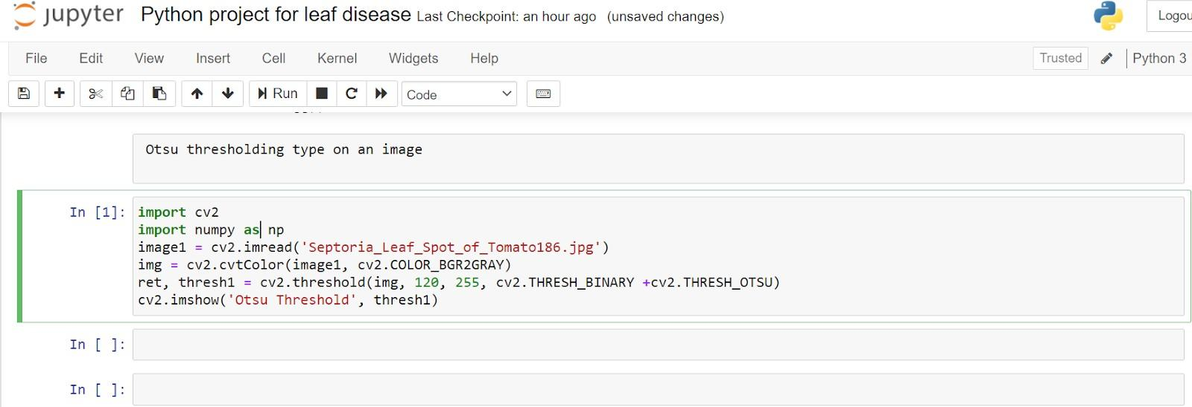

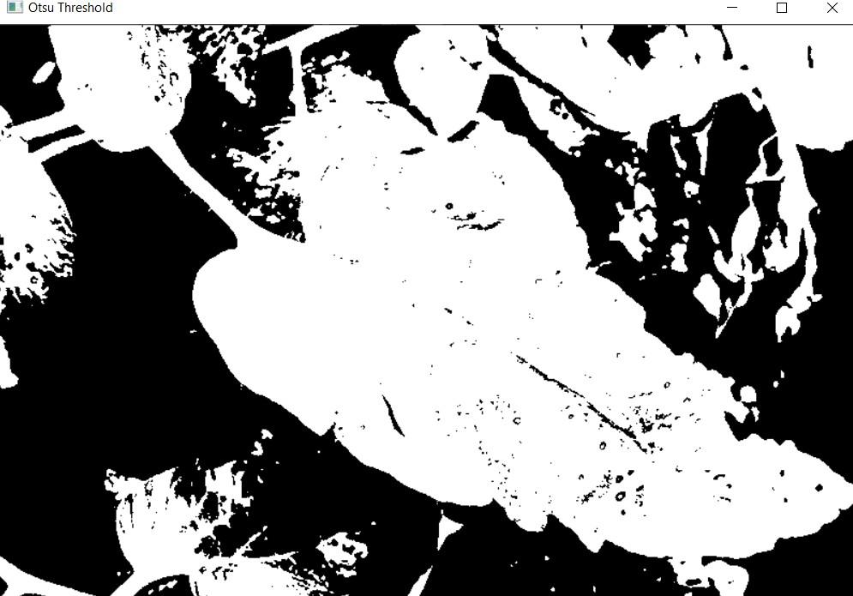

Figure 5.4: Output of Otsu Threshold

##### Step_4: K-Means Clustering.

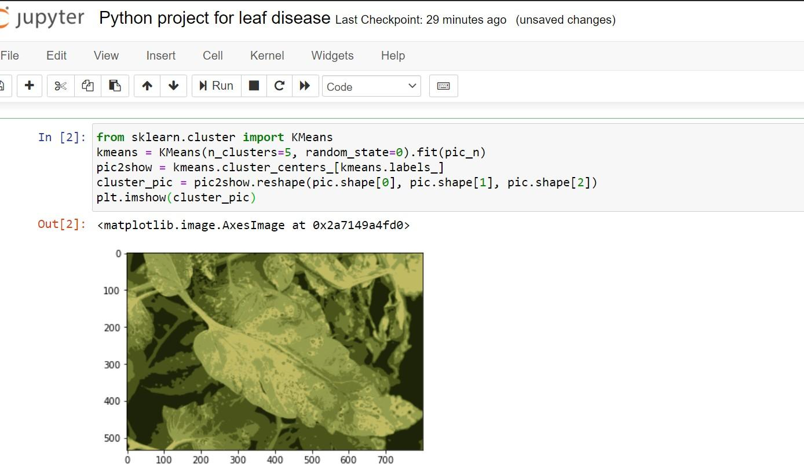

Figure 5.5: K-Means Clustering.

##### Step_5: Feature Extraction

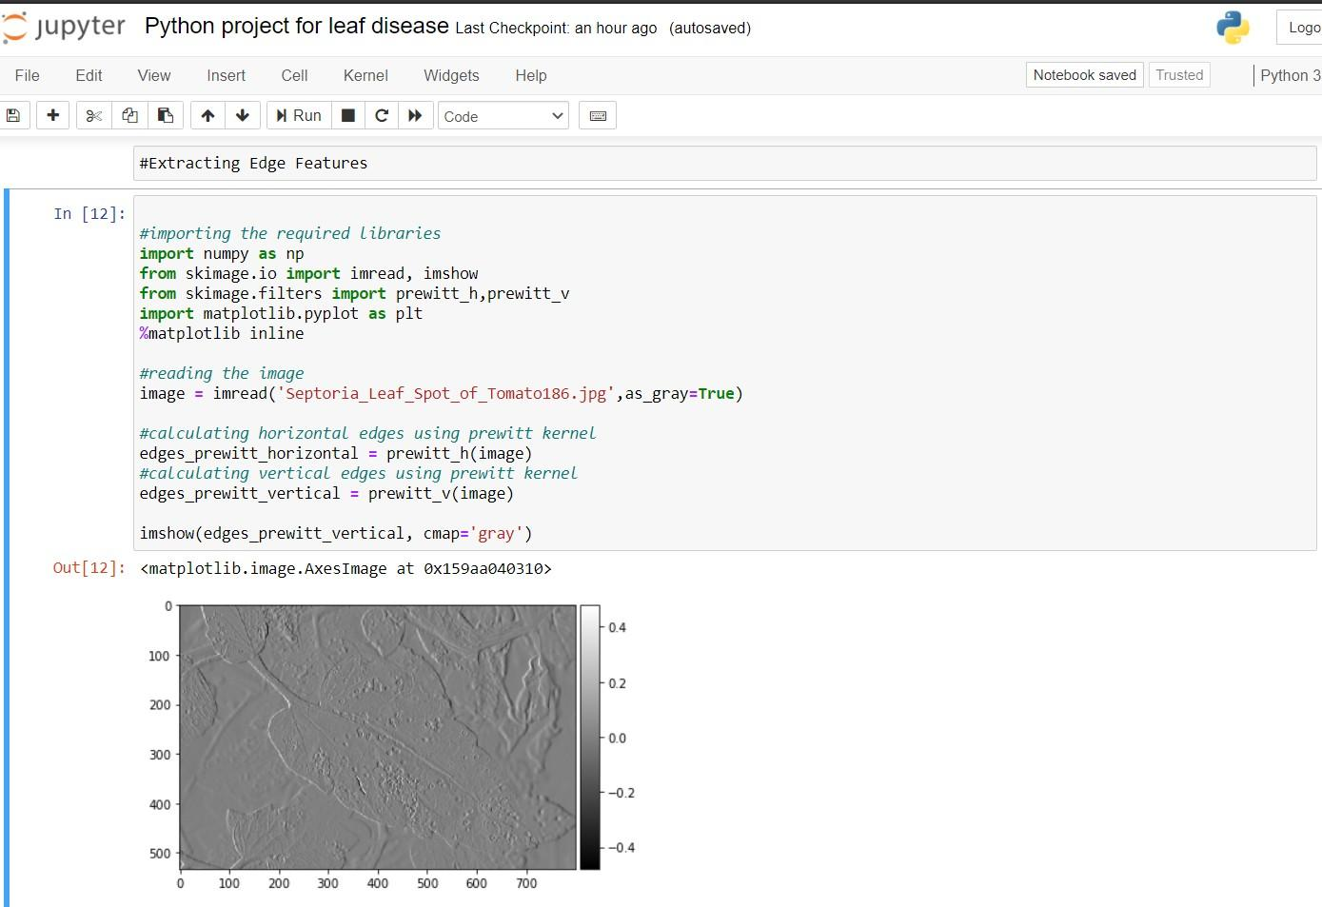

Figure 5.6: Feature Extraction

# Chapter 6

##### Conclusion

In this project, we are trying to help farmers to identify leaf disease. Here we have select tomato leaves to identify disease. Also in this project we are going to develop mobile application for the farmer where they will get notification regarding disease on leaf, also we can suggest pesticide for that identified disease.

##### Future Scope

* + - In future we will try to implement this project with the help of either CNN, SVM, etc algorithms.
    - Also we will design a mobile application for this project.

##### Advantages:

* The high number of leaves parameters obtained with one single measurement.
* The minimization of human errors.
* The reduction of time needed to obtain large data sets concerning leaves trait variability.
* The possibility to estimate variability in traits of leaves with complicated shapes.

##### Applications:

* Plant disease detection is one of the important agricultural applications to increase the yield.
* Also used to monitoring flowers and fruit gardens.

# Chapter 7 References:

1. Kaushik N, Nikhil K G, Sulagna Sarkar, “Plant Leaf Disease Detection and Soil Condition Monitoring System Using CNN and IOT” Journal of Xi'an University Of Architecture & Technology, Volume Xii, Issue VI, ISSN No: 1006-7930, 2020.
2. Faye Mohameth, Chen Bingcai, Kane Amath Sada, “Plant Disease Detection with Deep Learning and Feature Extraction Using Plant Village”, Journal of Computer And Communications, DOI: 10.4236/JCC. 2020.86002 Jun. 17, 2020.
3. Mr. Ashish Nage, Prof. V. R. Raut, “Detection and Identification of Plant Leaf Diseases Based On Python”, International Journal of Engineering Research & Technology (IJERT) ISSN: 2278- 0181 IJERT 050180 Vol. 8 Issue 05, May-2019.
4. Shantanu Kumbhar, Amita Nilawar, Shruti Patil, “Farmer Buddy-Web Based Cotton Leaf Disease Detection Using CNN”, International Journal of Applied Engineering Research ISSN 0973-4562 Volume 14, Pp. 2662-2666, 2019.
5. Abirami Devaraj, Karunya Rathan, Sarvepalli Jaahnavi And K Indira, “Identification Of Plant Disease Using Image Processing Technique” International Conference on Communication and Signal Processing, India, 978-1-5386-7595-3/1 April 4- 6, 2019.
6. Peng Jiang, Yuehan Chen, Bin Liu Dongjin He, And Chunquan Liang, “Real-Time Detection of Apple Leaf Diseases Using Deep Learning Approach Based on Improved Convolutional Neural Networks”, IEEE, Volume 7, 2019.
7. Vishakha Lahu Bansod, “Rice Crop Disease Identification and Classifier”,

International Journal of Computer Sciences and Engineering, Vol.-7, Special Issue- 11, May 2019.

1. Subhajit Maity, Sujan Sarkar, Avinaba Tapadar, Ayan Dutta, Sanket Biswas, Sayon Nayek, Pritam Saha, “Fault Area Detection in Leaf Diseases using k-means Clustering”, Jalpaiguri Government Engineering College INDIA.
2. S.S. Saranya, Nalluri Chandra Kiran, Komma Jyotheeswar Reddy, “Identification Of Diseases In-Plant Parts Using Image Processing”, International Journal of engineering & Technology, 7 (2.8) 461-463, 2018.
3. Xihai Zhang (Member, IEEE), Yue Qiao, Fanfeng Meng, Chengguo Fan, And Mingming Zhang, “Identification Of Maize Leaf Diseases Using Improved Deep Convolutional Neural Networks”, IEEE Volume 6, 2018.
4. Shalini K J, Hema M D, Kavya J, Meghana B N , Jeevitha M C ,“Leaf Disease Detection By Using Image Processing”, IJIRSET, Vol. 7, Issue 5, May 2018.
5. Saradhambal .G, Dhivya .R, Latha.S, R. Rajesh, “Plant Disease Detection and Its Solution Using Image Classification”, International Journal of Pure and Applied Mathematics Volume 119 No. 14, 879-884, 2018.
6. T. Thamil Azhagi1, K. Swethl, and M. Shravani1 & A.T. Madhavi, “Plant Pathology Detection and Control Using Raspberry Pi”, IJESRT, ISSN: 2277-9655, 2018.
7. Prof. Swati Pawar Ms.Shweta Patil Ms .Tejaswini Patil Mr. Nasruddin Shaikh,” Detection And Classification Of Unhealthy Regions Of Grapes Plant Using Texture”, IJSRD, T Vol. 5, Issue 04, 2017.
8. Vijai Singh, A. K. Misra, “Detection of Plant Leaf Diseases Using Image Segmentation And Soft Computing Techniques”, Information Processing In Agriculture 4, 41–49, 2017.
9. Priyanka G. Shinde, Ajay K. Shinde, Ajinkya A. Shinde, Borate S. P, “Plant Disease Detection Using Raspberry Pi By K-Means Clustering Algorithm”, IJEECS, ISSN: 2347-2820, Volume -5, Issue-1, 2017.
10. K. Narsimha Reddy, B.Polaiah, N.Madhu, “A Literature Survey: Plant Leaf Diseases Detection Using Image Processing Techniques”, (IOSR-JECE) E-ISSN: 2278-2834, P- ISSN: 2278-8735.Volume 12, Issue 3, VER. II, PP 13-15, 2017.
11. S.S. Lomte, A.P. Janwale, “Plant Leaves Image Segmentation Techniques: A Review”, International Journal of Computer Sciences and Engineering Vol. 5 (5), E-ISSN: 2347-2693, 2017.
12. Ajay K. Shinde, Priyanka G. Shinde, Ajinkya A. Shinde, “Plant Disease Detection Using Raspberry Pi By K-Means Clustering Algorithm” 2016.
13. Khushal Khairnar, Rahul Dagade, “Disease Detection and Diagnosis on Plant Using Image Processing”, International Journal of Computer Applications (0975 – 8887) Volume 108 – No. 13, December 2014.